**Machine Learning Written Homework**

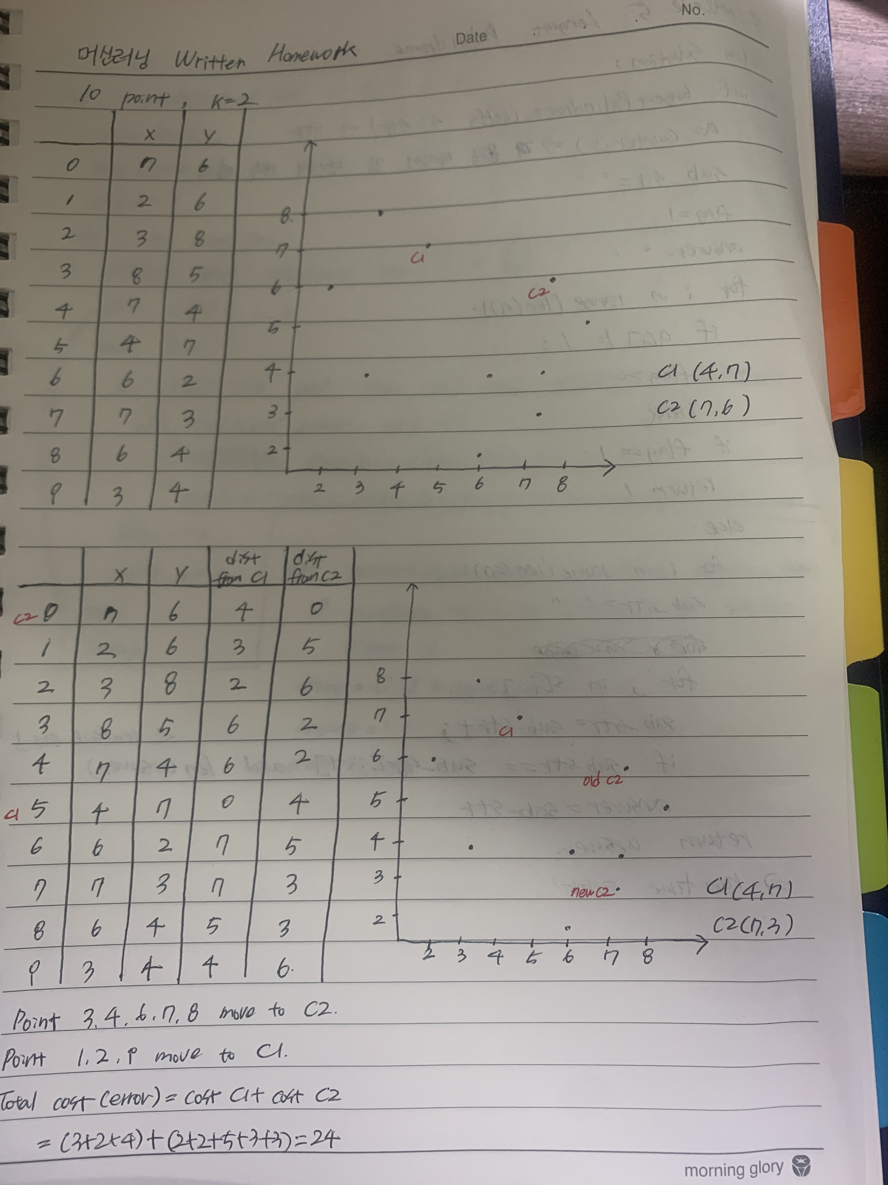

**------------------------------------------------------1-----------------------------------------------------**

**‘E’ step**

1. HTTTHHTHTH

P(S|A) = ${0.1}^{5}*(1-{0.1)}^{5}=5.9049000000000025e-06$

P(S|B) = ${0.9}^{5}*(1-{0.9)}^{5}=5.904899999999994e-06$

P(A|S) = P(S|A) * P(A) / P(S) = 0.5000000000000003

P(B|S) = P(S|B) * P(B) / P(S) = 0.49999999999999967

1. HHHHTHHHHH

P(S|A) = ${0.1}^{9}*(1-{0.1)}^{1}=9.000000000000004e-10$

P(S|B) = ${0.9}^{9}*(1-{0.9)}^{1}=0.0387420489$

P(A|S) = P(S|A) * P(A) / P(S) = 2.3230572585759273e-08

P(B|S) = P(S|B) * P(B) / P(S) = 0.9999999767694274

1. HTHHHHHTHH

P(S|A) = ${0.1}^{8}*(1-{0.1)}^{2}=8.100000000000005e-09$

P(S|B) = ${0.9}^{8}*(1-{0.9)}^{2}=0.004304672099999999$

P(A|S) = P(S|A) * P(A) / P(S) = 1.8816728824594235e-06

P(B|S) = P(S|B) * P(B) / P(S) = 0.9999981183271176

**‘M’ step**

p = 2.5000152624582146 / (2.5000152624582146 + 2.500003786576339) = 0.5

q = 19.499984737541787 / (19.499984737541787 + 5.49999621342366) = 0.78

**------------------------------------------------------2-----------------------------------------------------**

**‘E’ step**

1. HTTTHHTHTH

P(S|A) = ${0.5}^{5}*(1-{0.5)}^{5}=0.0009765624999742784$

P(S|B) = ${0.78}^{5}*(1-{0.78)}^{5}=0.00014879438138013144$

P(A|S) = P(S|A) * P(A) / P(S) = 0.8677802714450443

P(B|S) = P(S|B) * P(B) / P(S) = 0.1322197285549556

1. HHHHTHHHHH

P(S|A) = ${0.5}^{9}*(1-{0.5)}^{1}=0.0009765804311360135$

P(S|B) = ${0.78}^{9}*(1-{0.78)}^{1}=0.023511159942605473$

P(A|S) = P(S|A) * P(A) / P(S) = 0.039880381620805365

P(B|S) = P(S|B) * P(B) / P(S) = 0.9601196183791947

1. HTHHHHHTHH

P(S|A) = ${0.5}^{8}*(1-{0.5)}^{2}=0.0009765759483147134$

P(S|B) = ${0.78}^{8}*(1-{0.78)}^{2}=0.006631353429142704$

P(A|S) = P(S|A) * P(A) / P(S) = 0.12836290925732627

P(B|S) = P(S|B) * P(B) / P(S) = 0.8716370907426737

**‘M’ step**

p = 5.724728065871081 / (5.724728065871081 + 4.63550755736068) = 0.553

q = 16.27527193412892 / (16.27527193412892 + 3.36449244263932) = 0.829

**------------------------------------------------------3-----------------------------------------------------**

**‘E’ step**

1. HTTTHHTHTH

P(S|A) = ${0.553}^{5}*(1-{0.553)}^{5}=0.0009237712657633519$

P(S|B) = ${0.829}^{5}*(1-{0.829)}^{5}=5.7660223650898576e-05$

P(A|S) = P(S|A) * P(A) / P(S) = 0.9412488550929703

P(B|S) = P(S|B) * P(B) / P(S) = 0.05875114490702966

1. HHHHTHHHHH

P(S|A) = ${0.553}^{9}*(1-{0.553)}^{1}=0.002148793702760928$

P(S|B) = ${0.829}^{9}*(1-{0.829)}^{1}=0.03157265534810364$

P(A|S) = P(S|A) * P(A) / P(S) = 0.063721867334934

P(B|S) = P(S|B) * P(B) / P(S) = 0.936278132665066

1. HTHHHHHTHH

P(S|A) = ${0.553}^{8}*(1-{0.553)}^{2}=0.001739951545950276$

P(S|B) = ${0.829}^{8}*(1-{0.829)}^{2}=0.006526831670934906$

P(A|S) = P(S|A) * P(A) / P(S) = 0.21047504214170837

P(B|S) = P(S|B) * P(B) / P(S) = 0.7895249578582917

**‘M’ step**

p = 6.963541418612925 / (6.963541418612925 + 5.1909162270832025) = 0.573

q = 15.036458581387075 / (15.036458581387075 + 2.8090837729167975) = 0.843